Federico Vargas Rozo 16/02/2024

Parcial Práctico No. 1

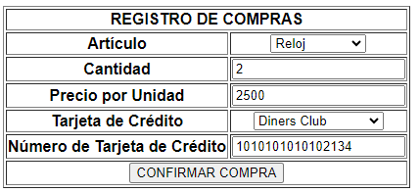

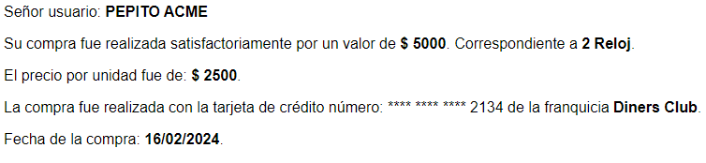

-------------------------------------------------------- 0 ------------------------------------------------------

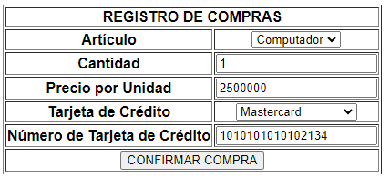

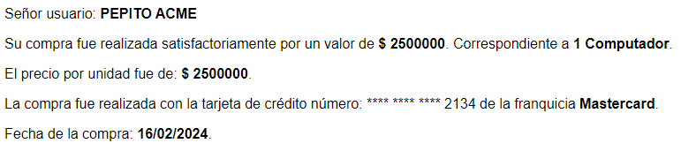

-------------------------------------------------------- 0 ------------------------------------------------------

